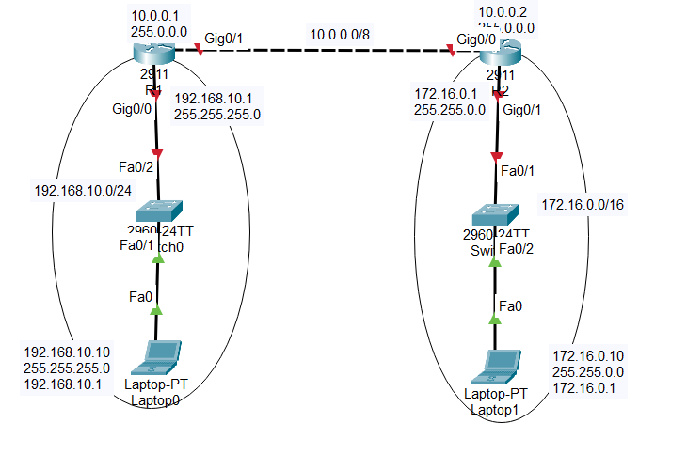

Configure IP address on Router R1 on interface gigabitEthernet 0/0 & 0/1:

|  |
| --- |
| R1>**enable**  R1#**configure terminal**  Enter configuration commands, one per line. End with CNTL/Z.  R1(config)#**interface gigabitEthernet 0/0**  R1(config-if)#ip add  R1(config-if)#**ip address 192.168.10.1 255.255.255.0**  R1(config-if)#**no shutdown**  R1(config-if)#  %LINK-5-CHANGED: Interface GigabitEthernet0/0, changed state to up  %LINEPROTO-5-UPDOWN: Line protocol on Interface GigabitEthernet0/0, changed state to up  R1(config-if)#**exit**  R1(config)#  R1(config)#**interface gigabitEthernet 0/1**  R1(config-if)#ip add  R1(config-if)#**ip address 10.0.0.1 255.0.0.0**  R1(config-if)#no shi  R1(config-if)#no sh  R1(config-if)#**no shutdown**  R1(config-if)#  %LINK-5-CHANGED: Interface GigabitEthernet0/1, changed state to up  R1(config-if)# |

Configure IP address on Router R2 on interface gigabitEthernet 0/0 & 0/1:

|  |
| --- |
| R2>en  R2>**enable**  R2#**configure terminal**  Enter configuration commands, one per line. End with CNTL/Z.  R2(config)#**interface gigabitEthernet 0/1**  R2(config-if)#**ip address 172.16.0.1 255.255.0.0**  R2(config-if)#**no shutdown**  R2(config-if)#  %LINK-5-CHANGED: Interface GigabitEthernet0/1, changed state to up  %LINEPROTO-5-UPDOWN: Line protocol on Interface GigabitEthernet0/1, changed state to up  R2(config-if)#**exit**  R2(config)#**interface gigabitEthernet 0/0**  R2(config-if)#**ip address 10.0.0.2 255.0.0.0**  R2(config-if)#**no shutdown**  R2(config-if)#  %LINK-5-CHANGED: Interface GigabitEthernet0/0, changed state to up  %LINEPROTO-5-UPDOWN: Line protocol on Interface GigabitEthernet0/0, changed state to up  R2(config-if)# |

**Configuring STATIC ROUTING on Router R1**:

|  |
| --- |
| R1>enable  R1#conf  R1#configure t  R1#configure terminal  Enter configuration commands, one per line. End with CNTL/Z.  R1(config)#ip route  R1(config)#ip route 172.16.0.0 255.255.0.0 10.0.0.2  R1(config)# |

**Configuring STATIC ROUTING on Router R2**:

|  |
| --- |
| R2>enable  R2#conf  R2#configure t  R2#configure terminal  Enter configuration commands, one per line. End with CNTL/Z.  R2(config)#ip route 192.168.10.0 255.255.255.0 10.0.0.1  R2(config)#    Ping from Laptop 0 to Laptop 1: |

2 router configuration using RIPv2

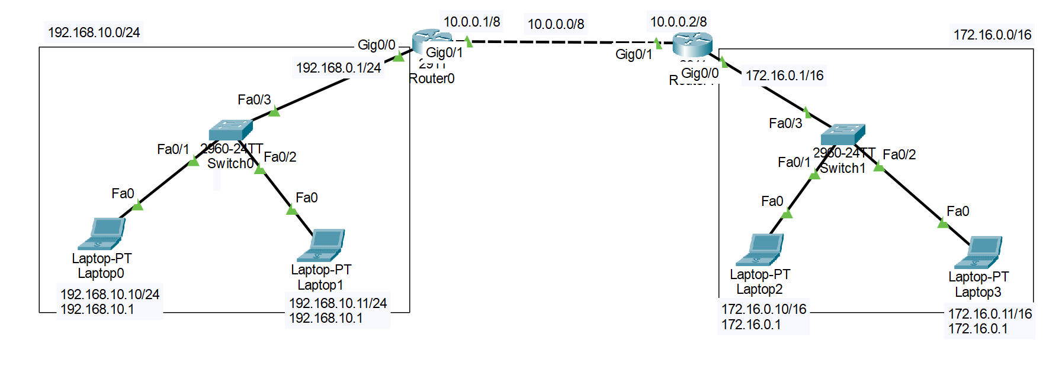

Configuring Router 0

|  |
| --- |
| Router>enable  Router#configure terminal  Enter configuration commands, one per line. End with CNTL/Z.  Router(config)#  Router(config)#router rip  Router(config-router)#version 2  Router(config-router)#network 192.168.10.0  Router(config-router)#network 10.0.0.0  Router(config-router)#exit  Router(config)#  Router(config)#exit  Router#  %SYS-5-CONFIG_I: Configured from console by console  Router#copy running-config startup-config  Destination filename [startup-config]?  Building configuration...  [OK]  Router# |

Configuring Router 1

|  |
| --- |
| Router>enable  Router#configure terminal  Enter configuration commands, one per line. End with CNTL/Z.  Router(config)#router rip  Router(config-router)#version 2  Router(config-router)#network 10.0.0.0  Router(config-router)#network 172.16.0.0  Router(config-router)#exit  Router(config)#exit  Router#  %SYS-5-CONFIG_I: Configured from console by console  Router#copy running-config startup-config  Destination filename [startup-config]?  Building configuration...  [OK]  Router# |